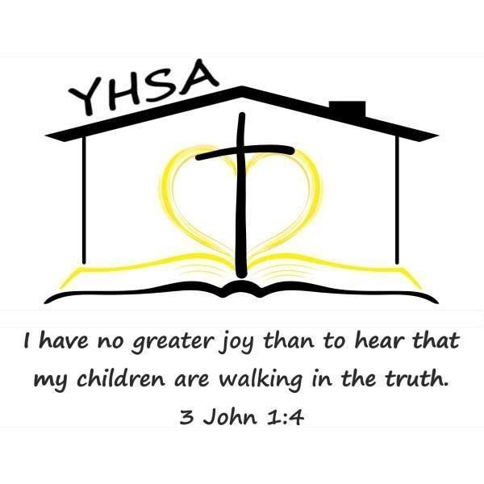
2024 Evaluator Questionnaire

Name: Rebecca Monticchio Date: March 19, 2024

Are you a current or alumni member of YHSA? NEITHER

- Which of the following are you qualified/approved to do: (Please check all that apply)

    - Elementary & Secondary Evaluations (beginner through grade 8)

- Under which of the following do you evaluate in Pennsylvania? (Please check all that apply.)

- Teacher certified by the Commonwealth with at least two years of experience at the elementary level (through grade 8) grading any of the following subjects: English, to include spelling, reading, and writing; arithmetic; science; geography; history of the United States and Pennsylvania; and civics.

- Do you currently or have you ever educated your own children/grandchildren at home?

YES, under Home Ed Law

If yes, what ages of children or number of years? I homeschooled my daughters through grade 6.

- How long have you been conducting home education program evaluations? 20 years

- What is your educational philosophy? A mix of Charlotte Mason and Classical

- What types of home education programs do you have experience evaluating? (Circle all that apply)

Traditional School at Home * Relaxed/Eclectic * Classical Conversations * Charlotte Mason

- Where/how do you conduct evaluations: Circle all that apply.

Your home Client’s home Public places such as parks, etc.

Video chat/Zoom

- The PA Home Education Law states an “annual written evaluation of a student’s academic progress…. shall also be based on an interview of the child and a review of the portfolio...and shall certify whether or not an appropriate education is occurring.” Portfolio is defined as “a log, made contemporaneously with the instruction, which designates by title the reading materials used, samples of any writings, worksheets, workbooks or creative materials used or developed by the student and in grades three, five and eight results of nationally-normed standardized achievement tests in reading/language arts and mathematics or the results of Statewide tests administered in these grade levels.” Appropriate education is defined as, “a program consisting of instruction in the required subjects for the time required in this act and in which the student demonstrates sustained progress in the overall program.”

What do you require families to provide in their portfolio or interview to demonstrate progress?

Samples of work from the beginning, middle, and end of the school year. Examples: assessments, papers, curriculum sheets, list of memory work, projects or activities.
Calendar and Reading Log

- What is your religious affiliation, if any? Christian

- What is your fee for evaluations? $50 at my home $60 traveling

- If qualified, what is your fee for special needs objectives approval? n/a

- Do you have references available upon request? YES

- Please indicate your preferred method of contact:

EMAIL: rebecca.monticchio@logosyork.org

TELEPHONE: 717-917-6045 TEXT/ YES

